**How to Install Python 3 and Set Up a Local Programming Environment on Ubuntu 16.04**

**Introduction**

This tutorial will get you up and running with a local Python 3 programming environment in Ubuntu 16.04.

Python is a versatile programming language that can be used for many different programming projects. First published in 1991 with a name inspired by the British comedy group Monty Python, the development team wanted to make Python a language that was fun to use. Easy to set up, and written in a relatively straightforward style with immediate feedback on errors, Python is a great choice for beginners and experienced developers alike. Python 3 is the most current version of the language and is considered to be the future of Python.

This tutorial will guide you through installing Python 3 on your local Linux machine and setting up a programming environment via the command line. This tutorial will explicitly cover the installation procedures for Ubuntu 16.04, but the general principles apply to any other distribution of Debian Linux.

Prerequisites

You will need a computer with Ubuntu 16.04 installed, as well as have administrative access to that machine and an internet connection.

Step 1 — Setting Up Python 3

We’ll be completing our installation and setup on the command line, which is a non-graphical way to interact with your computer. That is, instead of clicking on buttons, you’ll be typing in text and receiving feedback from your computer through text as well. The command line, also known as a shell, can help you modify and automate many of the tasks you do on a computer every day, and is an essential tool for software developers. There are many terminal commands to learn that can enable you to do more powerful things. The article “[An Introduction to the Linux Terminal](https://www.digitalocean.com/community/tutorials/an-introduction-to-the-linux-terminal)” can get you better oriented with the terminal.

On Ubuntu 16.04, you can find the Terminal application by clicking on the Ubuntu icon in the upper-left hand corner of your screen and typing “terminal” into the search bar. Click on the Terminal application icon to open it. Alternatively, you can hit the CTRL, ALT, and T keys on your keyboard at the same time to open the Terminal application automatically.

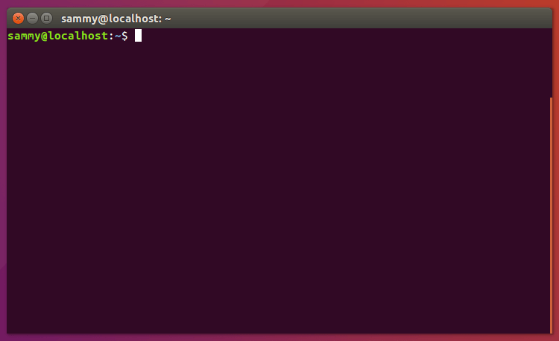

Ubuntu 16.04 ships with both Python 3 and Python 2 pre-installed. To make sure that our versions are up-to-date, let’s update and upgrade the system with apt-get:

* sudo apt-get update
* sudo apt-get -y upgrade

The -y flag will confirm that we are agreeing for all items to be installed, but depending on your version of Linux, you may need to confirm additional prompts as your system updates and upgrades.

Once the process is complete, we can check the version of Python 3 that is installed in the system by typing:

* python3 -V

You will receive output in the terminal window that will let you know the version number. The version number may vary, but it will look similar to this:

Output

Python 3.5.2

To manage software packages for Python, let’s install **pip**:

* sudo apt-get install -y python3-pip

**How to upgrade pip**

pip install --upgrade pip

And in Python 3 this works:

python3 -m pip install --upgrade pip setuptools wheel

or

sudo -H pip3 install --upgrade pip

A tool for use with Python, **pip** installs and manages programming packages we may want to use in our development projects. You can install Python packages by typing:

* pip3 install package_name

Here, package_name can refer to any Python package or library, such as Django for web development or NumPy for scientific computing. So if you would like to install NumPy, you can do so with the command pip3 install numpy.

There are a few more packages and development tools to install to ensure that we have a robust set-up for our programming environment:

* sudo apt-get install build-essential libssl-dev libffi-dev python-dev

Once Python is set up, and pip and other tools are installed, we can set up a virtual environment for our development projects.

Step 2 — Setting Up a Virtual Environment

Virtual environments enable you to have an isolated space on your computer for Python projects, ensuring that each of your projects can have its own set of dependencies that won’t disrupt any of your other projects.

Setting up a programming environment provides us with greater control over our Python projects and over how different versions of packages are handled. This is especially important when working with third-party packages.

You can set up as many Python programming environments as you want. Each environment is basically a directory or folder in your computer that has a few scripts in it to make it act as an environment.

We need to first install the **venv** module, part of the standard Python 3 library, so that we can create virtual environments. Let’s install venv by typing:

* sudo apt-get install -y python3-venv

With this installed, we are ready to create environments. Let’s choose which directory we would like to put our Python programming environments in, or we can create a new directory with mkdir, as in:

* mkdir environments
* cd environments

Once you are in the directory where you would like the environments to live, you can create an environment by running the following command:

* python3 -m venv my_env

Essentially, this sets up a new directory that contains a few items which we can view with the lscommand:

* ls my_env

Output

bin include lib lib64 pyvenv.cfg share

Together, these files work to make sure that your projects are isolated from the broader context of your local machine, so that system files and project files don’t mix. This is good practice for version control and to ensure that each of your projects has access to the particular packages that it needs. Python Wheels, a built-package format for Python that can speed up your software production by reducing the number of times you need to compile, will be in the Ubuntu 16.04 share directory.

To use this environment, you need to activate it, which you can do by typing the following command that calls the activate script:

* source my_env/bin/activate

Your prompt will now be prefixed with the name of your environment, in this case it is called my_env. Your prefix may look somewhat different, but the name of your environment in parentheses should be the first thing you see on your line:

This prefix lets us know that the environment my_env is currently active, meaning that when we create programs here they will use only this particular environment’s settings and packages.

**Note:** Within the virtual environment, you can use the command python instead of python3, and pipinstead of pip3 if you would prefer. If you use Python 3 on your machine outside of an environment, you will need to use the python3 and pip3 commands exclusively. 

After following these steps, your virtual environment is ready to use.

Step 3 — Creating a Simple Program

Now that we have our virtual environment set up, let’s create a simple “Hello, World!” program. This will make sure that our environment is working and gives us the opportunity to become more familiar with Python if we aren’t already.

To do this, we’ll open up a command-line text editor such as nano and create a new file:

* nano hello.py

Once the text file opens up in the terminal window we’ll type out our program:

print("Hello, World!")

Exit nano by typing the control and x keys, and when prompted to save the file press y.

Once you exit out of nano and return to your shell, let’s run the program:

* python hello.py

The hello.py program that you just created should cause your terminal to produce the following output:

Output

Hello, World!

To leave the environment, simply type the command deactivate and you will return to your original directory.

Conclusion

Congratulations! At this point you have a Python 3 programming environment set up on your local Ubuntu machine and can begin a coding project!

**Scientific Python distributions**

## Installing via pip

Most major projects upload official packages to the [Python Package index](https://pypi.org/). They can be installed on most operating systems using Python’s standard [pip](https://pip.pypa.io/en/stable) package manager.

Note that you need to have Python and pip already installed on your system.

You can install packages via commands such as:

python -m pip install --user numpy scipy matplotlib ipython jupyter pandas sympy nose

We recommend using an user install, using the --user flag to pip (note: do not use sudo pip, which can cause problems). This installs packages for your local user, and does not write to the system directories.

**Install system-wide via a Linux package manager**

Users on Linux can install packages from repositories provided by the distributions. These installations will be system-wide, and may have older package versions than those available using pip.

Ubuntu & Debian (This works better, make sure to substitute python with python3)

sudo apt-get install python-numpy python-scipy python-matplotlib ipython ipython-notebook python-pandas python-sympy python-nose

Users might also want to add the [NeuroDebian repository](http://neuro.debian.net/) for extra SciPy packages.

(This works for numpy but not for scipy, also inside the virtual environment pip should again be upgraded.)

Pip3 install numpy

"sudo apt-get install ipython"

"sudo apt-get install python-numpy"

"sudo apt-get install python-matplotlib"

"sudo apt-get install geany"

How to run ipython: ipython –pylab. (for using iPython matplotlib old should also be installed.)

**PySerial Installation**

Pip3 install pyserial should work for most users.